**Homework SQL**

1. SELECT * FROM cd.facilities;

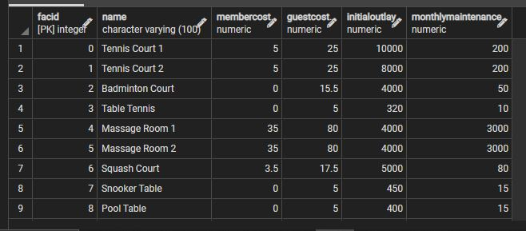

1. SELECT

name,

membercost

FROM cd.facilities;

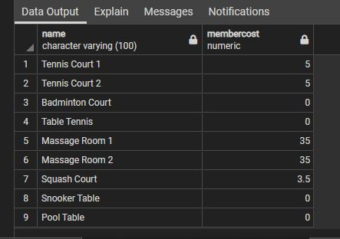

1. SELECT *

FROM cd.facilities

WHERE membercost > 0;

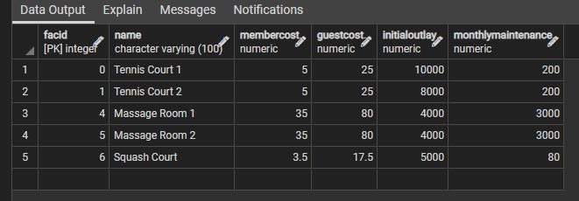

1. SELECT

facid,

name,

membercost,

monthlymaintenance

FROM cd.facilities

WHERE

membercost > 0

AND membercost < (monthlymaintenance/50);

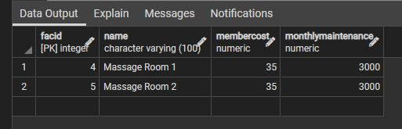

1. SELECT *

FROM cd.facilities

WHERE name ILIKE '%tennis%';

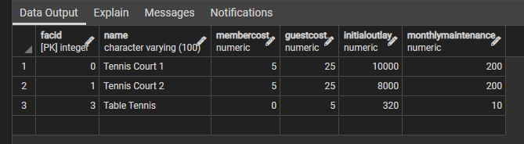

1. SELECT *

FROM cd.facilities

WHERE facid IN (1, 5);

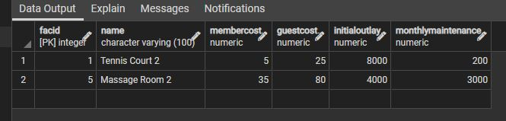

1. SELECT

memid,

surname,

firstname,

joindate

FROM cd.members

WHERE joindate >= '2012-09-01';

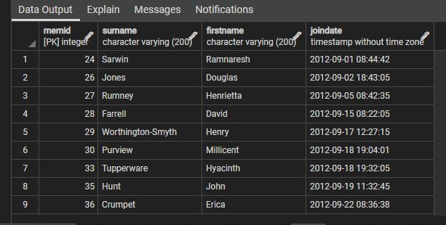

1. SELECT

DISTINCT surname

FROM cd.members

ORDER BY 1

LIMIT 10;

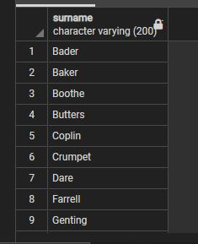

1. SELECT MAX(joindate)

FROM cd.members;



1. SELECT COUNT(*)

FROM cd.facilities

WHERE guestcost >= 10;

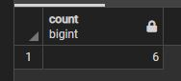

1. SELECT

facid,

SUM(slots) AS total_slots

FROM cd.bookings

WHERE

starttime BETWEEN '2012-09-01' AND '2012-10-01'

GROUP BY 1

ORDER BY 2;

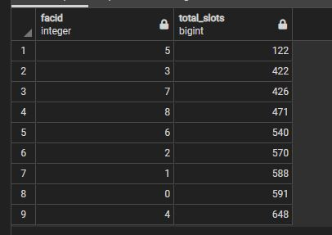

1. SELECT

f.facid,

SUM(b.slots) AS Total_Slots

FROM cd.facilities AS f

FULL OUTER JOIN cd.bookings AS b

ON f.facid = b.facid

GROUP BY 1

HAVING SUM(b.slots) > 1000

ORDER BY 1;

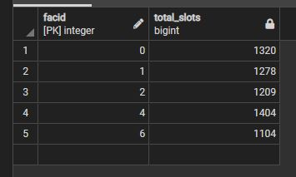

1. SELECT

b.starttime AS start,

f.name

FROM cd.bookings b

INNER JOIN cd.facilities f

ON b.facid = b.facid

WHERE

name ILIKE '%tennis court%'

AND b.starttime BETWEEN '2012-09-21' AND '2012-09-22'

ORDER BY 1;

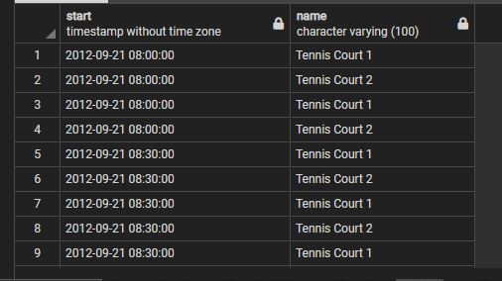

1. SELECT

m.memid,

m.surname,

m.firstname,

m.joindate,

b.starttime

FROM cd.members m

FULL OUTER JOIN cd.bookings b

ON m.memid=b.memid

WHERE

m.firstname ILIKE '%david%' AND

m.surname ILIKE '%Farrell;

